**Pi-Star HotSpot Config**

Dashboard accessible via http://pi-star

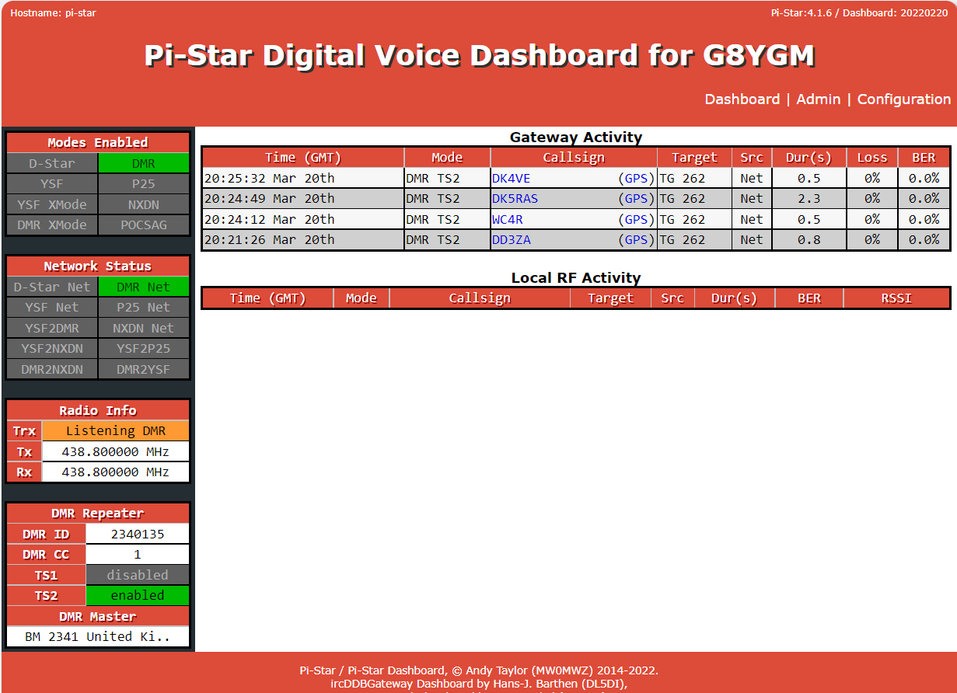

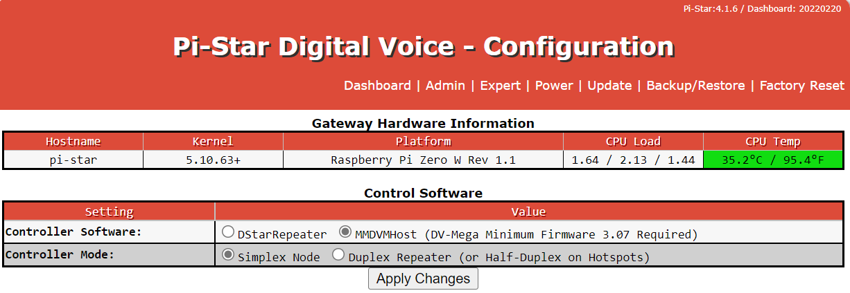

Ensure MMDVMHost controller is selected and as this will not operate as a repeater ensure that Simplex Mode is selected

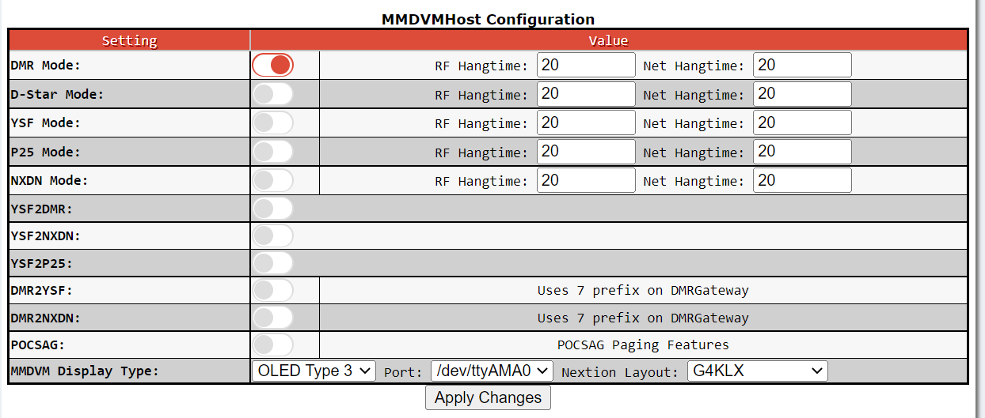

Initially only DMR Mode will be selected, leave the hangtimes as default, this ensures a delay is introduced between overs before it scans any other channels

The display is set to OLED 3 at /dev/tty/AMA0 with a G4KLX layout

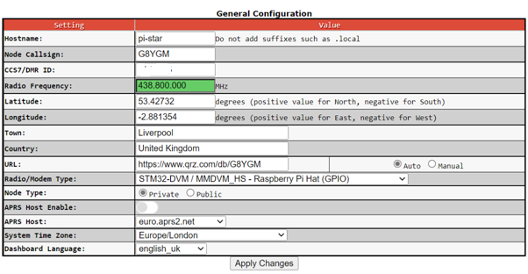

Enter details as above (DMR ID has been obscured, the frequency is the frequency required to create the channels on the digital radio. Ensure correct modem is selected

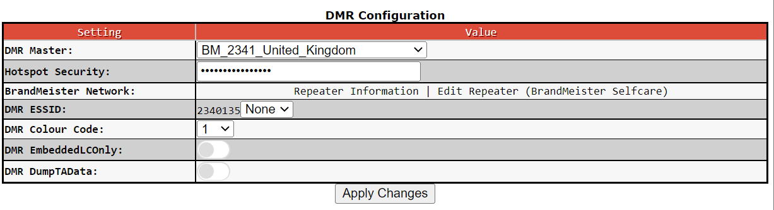

Ensure the DMR Master is set to BM 2341 UK and enter the password that was setup in the Brandmeister site self care

BrandMeister SelfCare Dashboard hyperlink takes you to your own settings on BrandMeister and can show the current dashboard as below

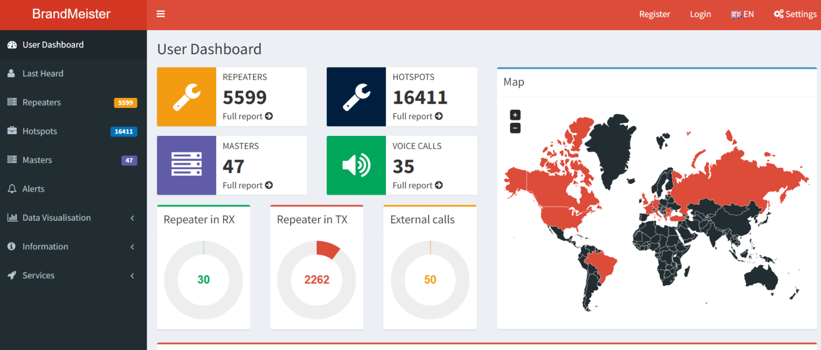

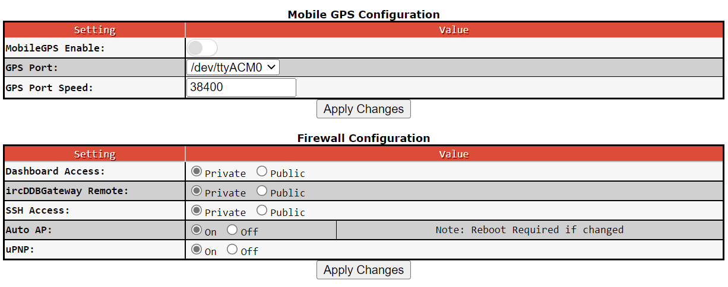

GPS is not enabled and for the UK the firewall has to be set to private

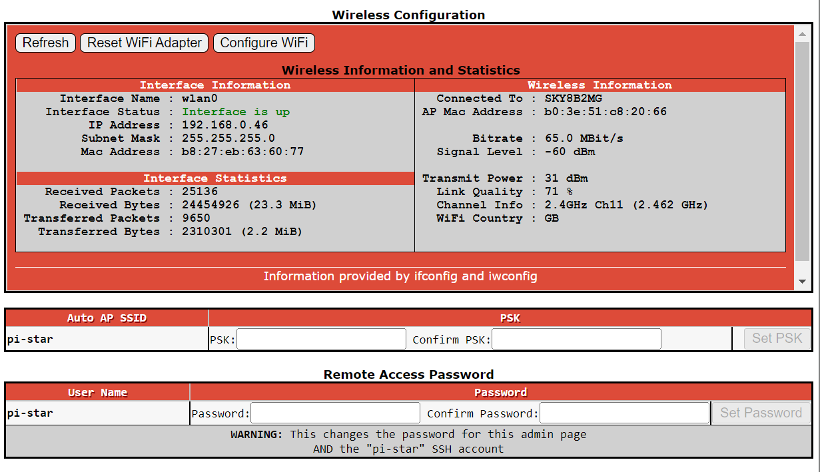

Once the wifi is set up by the addition of the wireless network configuration file the info can be seen as above